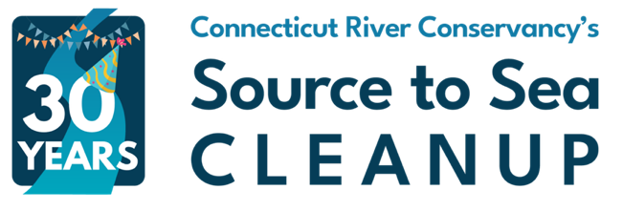

FOR IMMEDIATE RELEASE

CONTACT:
[add local group leader as primary contact]

Stacey Lennard, Connecticut River Conservancy Cleanup Coordinator
slennard@ctriver.org, 413-325-5995

[Group Name] Prepares for Day of Community Action as Part of Source to Sea Cleanup
[Location, Date]: Local community group organized by [name of group leader or organization] is preparing for a volunteer trash cleanup at [location]. [add any additional details here that are unique to your group, the trash site, or the local community.
This event is part of the Connecticut River Conservancy’s (CRC) 30th annual Source to Sea Cleanup. The goal is to remove as much trash as possible from local waterways, riverbanks, and communities to reduce the impact of pollution across the 410-mile Connecticut River watershed, including the tributaries that feed the mainstem river in NH, VT, MA, and CT.
What began in 1996 with a small group of volunteers dedicated to clean water and healthy habitats has grown to a massive community action trash removal event. Brought together by a shared passion for trash-free waterways, countless communities, businesses, nonprofits, and families now participate throughout the Connecticut River watershed.
Group leaders like [your group name] organize cleanup events at various trash sites based on areas of high need, while volunteers donate their time and effort to haul and clear tons of waste. Local municipalities support by providing dumpsters, waiving disposal fees, or collecting the trash from locations after the volunteers have completed their cleanups. Those interested in joining can sign up for [your group name]’s event here [link to your group page] or see additional events on CRC’s new platform at SourceToSeaCleanup.org.
Trash tallies are also gathered after each cleanup, contributing to CRC’s long-standing database which is used to inform the nonprofit’s work in advocacy to reduce future pollution, support river restoration, and inform the public and policymakers of issues affecting the environment. This event often includes participation from local legislative leaders.
Last year’s cleanup included 126 groups and 2,029 volunteers throughout four watershed states, who collectively removed 35.74 tons of trash from rivers and riverside areas (that’s over 71,480 lbs). [If you’ve participated in the past, you can edit this section with any specific data from your past events]. A wide variety of waste was collected by volunteers, including 16,079 beverage containers, 389 tires, and 7,255 lbs. of scrap metal in addition to cigarette butts, fishing equipment, food packaging, and common household items. Since data collection began in 1999, 1,182 tons of trash has been documented as removed from the watershed—and not everyone submits detailed data!
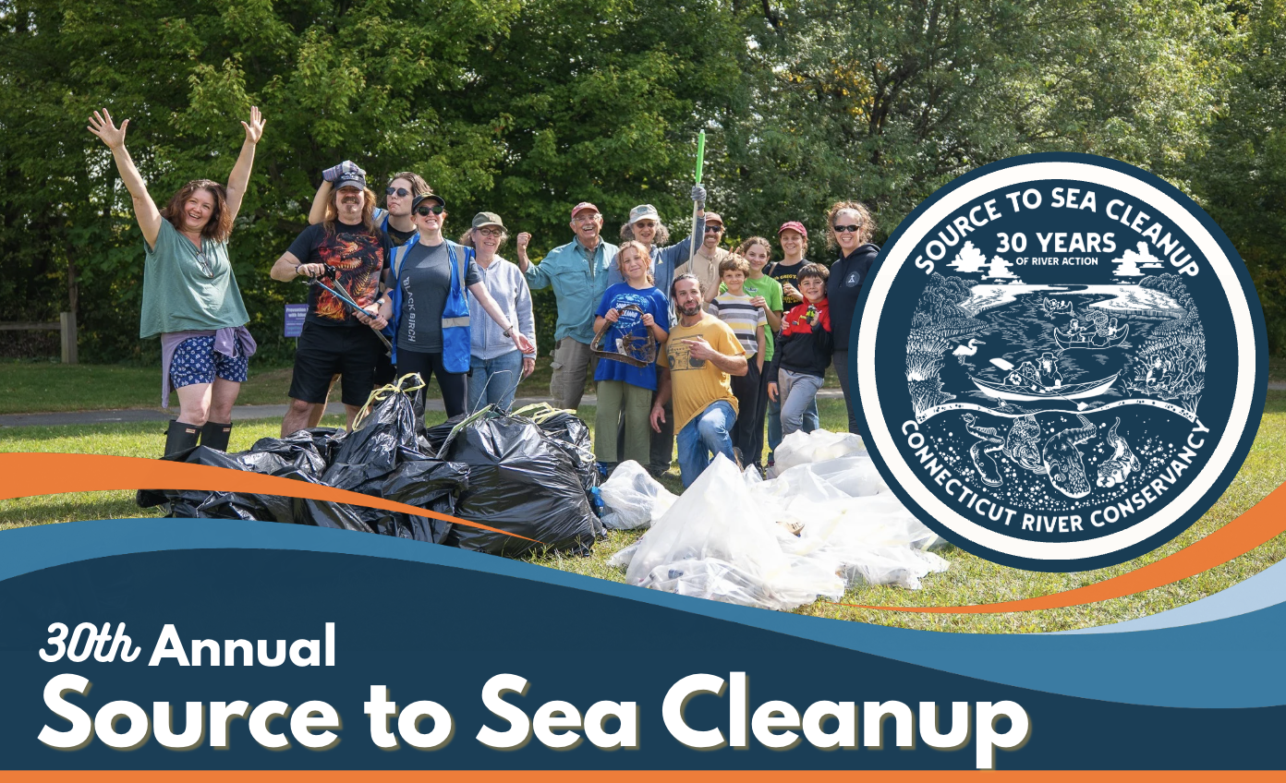
CRC will use #SourcetoSeaCleanup on Instagram to connect volunteers and is encouraging social media sharing of the cleanup experience.
“[add a quote here from someone local who will be participating with you or has participated in the past]” -name, title if applicable
“The Source to Sea Cleanup is an opportunity to get dirty for cleaner rivers, work with others in your community, and clean up our waterways and city streets,” says CRC’s Cleanup Coordinator, Stacey Lennard. “When you pick up trash you are diverting that waste from going down storm drains and into the river system, which eventually flows into the ocean. You are ensuring that we keep this debris out of our rivers and oceans.”
Group leaders who need help finding a cleanup site can check out CRC's map of adoptable trash sites. Or they can choose a site of their own by submitting a “Report a Trash Site” form. Parks, city blocks, boat ramps, and neighborhood hangouts are typically great spots to clean up. Trash travels, so even picking up litter off a city sidewalk can help protect wildlife and communities that depend on clean waterways. Group leaders are encouraged to scout the site beforehand to determine if it’s suitable for their group. A handy Group Leader Guide is available for download on the Source to Sea website and provides all the necessary information and forms for running a successful cleanup.
Connecticut River Conservancy would also like to thank the following sponsors for supporting this initiative – in some cases for many years! Presenting sponsors for 2026 are U.S.A. Waste & Recycling Inc., All American Waste, and The Antonacci Family Foundation. Watershed Sponsor: Eversource. River Sponsor: The Walker Group. Tributary Sponsors: Berkshire Home Company, Hypertherm HOPE Foundation. Stream Sponsors: Aquarion Water Company, Connecticut River Gateway Commission, Greenfield Savings Bank, and Savings Bank of Walpole. Ripple Effect Sponsors: Ascend Bank in partnership with Community Foundation of Middlesex County, Enterprise Mobility Fdn/Taylor Charitable Entities, Florence Bank, Fuss & O'Neill, Jamrog HVAC, Inc., New Chapter, Inc., Reynolds' Subaru, Rotary Club of Lebanon, Silver Screen Design, SLR International Corporation, SumCo Eco Contracting, SWCA Environmental Consultants, Tighe & Bond, Walmart (Northampton, MA), Westfield Bank. For more information, visit CRC’s cleanup info page.
Sign up for [group name] here.
To sign up as a volunteer or group leader, view the Cleanup Sites Map here.
For any questions about getting involved, contact Stacey Lennard at cleanup@ctriver.org.

About [your group]:

About Connecticut River Conservancy:
The Connecticut River Conservancy (CRC) restores and advocates for clean water, healthy habitats, and resilient communities to support a diverse and thriving watershed. CRC has been a steward of the Connecticut River and tributary streams since 1952. Their programs include advocacy, aquatic invasive species management, dam removal, habitat restoration, migratory fish surveys, recreation, trash cleanups, and water quality monitoring. Together through community engagement and education, they’re dedicated to ensuring equitable access and healthy rivers for all. Learn more at ctriver.org.

Photos from past Source to Sea Cleanups available here.
[replace with your own photos if you have them, or use the photos link if you don’t]

