￼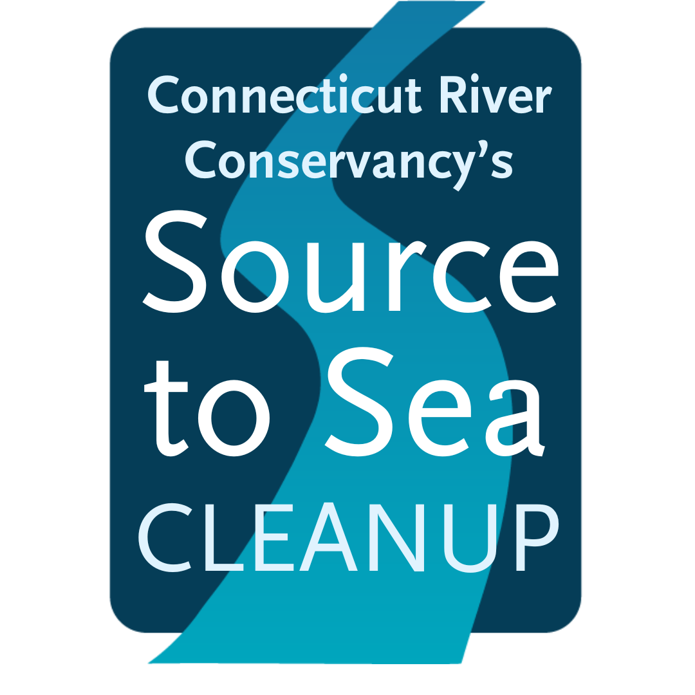

**FOR IMMEDIATE RELEASE**

**CONTACT:**

[add local group leader as primary contact]

Stacey Lennard, CRC Cleanup Coordinator

[slennard@ctriver.org](mailto:slennard@ctriver.org), 413-772-2020 ext.211

**[Group Name] Prepares for Day of Community Action as Part of Source to Sea Cleanup**

**[Location, Date]:** Local community group organized by [name of group leader or organization] is preparing for a volunteer trash cleanup at [location]. [add any additional details here that are unique to your group, the trash site, or the local community.

This event is part of the Connecticut River Conservancy’s (CRC) 28th annual Source to Sea Cleanup. The goal is to remove as much trash as possible from local waterways, riverbanks, and communities to reduce the impact of pollution across the 410-mile Connecticut River watershed, including the tributaries that feed the mainstem river in NH, VT, MA, and CT.

What began in 1997 with a small group of student volunteers dedicated to clean water and healthy habitats has grown to a massive community action trash removal event. Brought together by a shared passion for litter-free environments, countless communities, businesses, nonprofits, and families now participate throughout the Connecticut River watershed.

Group leaders like [your group name] organize cleanup events at various trash sites based on areas of high need, while volunteers donate their time and effort to haul and clear tons of waste. Local municipalities support by providing dumpsters, waiving disposal fees, or collecting the trash from locations after the volunteers have completed their cleanups. Those interested in joining can sign up for [your group name]’s event here [link to your group page] or see additional events on CRC’s new platform at [SourceToSeaCleanup.org.](https://sourcetoseacleanup.org/)

Trash tallies are also gathered after each cleanup, contributing to CRC’s long-standing database which is used to inform the nonprofit’s work in advocacy to reduce future pollution, support river restoration, and inform the public and policymakers of issues affecting the environment. This event often includes participation from local legislative leaders.

Last year’s cleanup included 126 groups and over 1,200 volunteers throughout four watershed states, who collectively removed 34.2 tons of trash from rivers and riverside areas. [If you’ve participated in the past, you can edit this section with any specific data from your past events] A wide variety of waste was collected by volunteers, including many bottles, cans, and cigarette butts, fishing equipment, food packaging, tires, appliances, mechanical objects, and even a hot tub. Over 9K beverage containers and over 13K lbs. of scrap metal were tallied in 2023 alone. Since data collection began in 1999, over 1,107 tons of trash has been removed from the watershed.

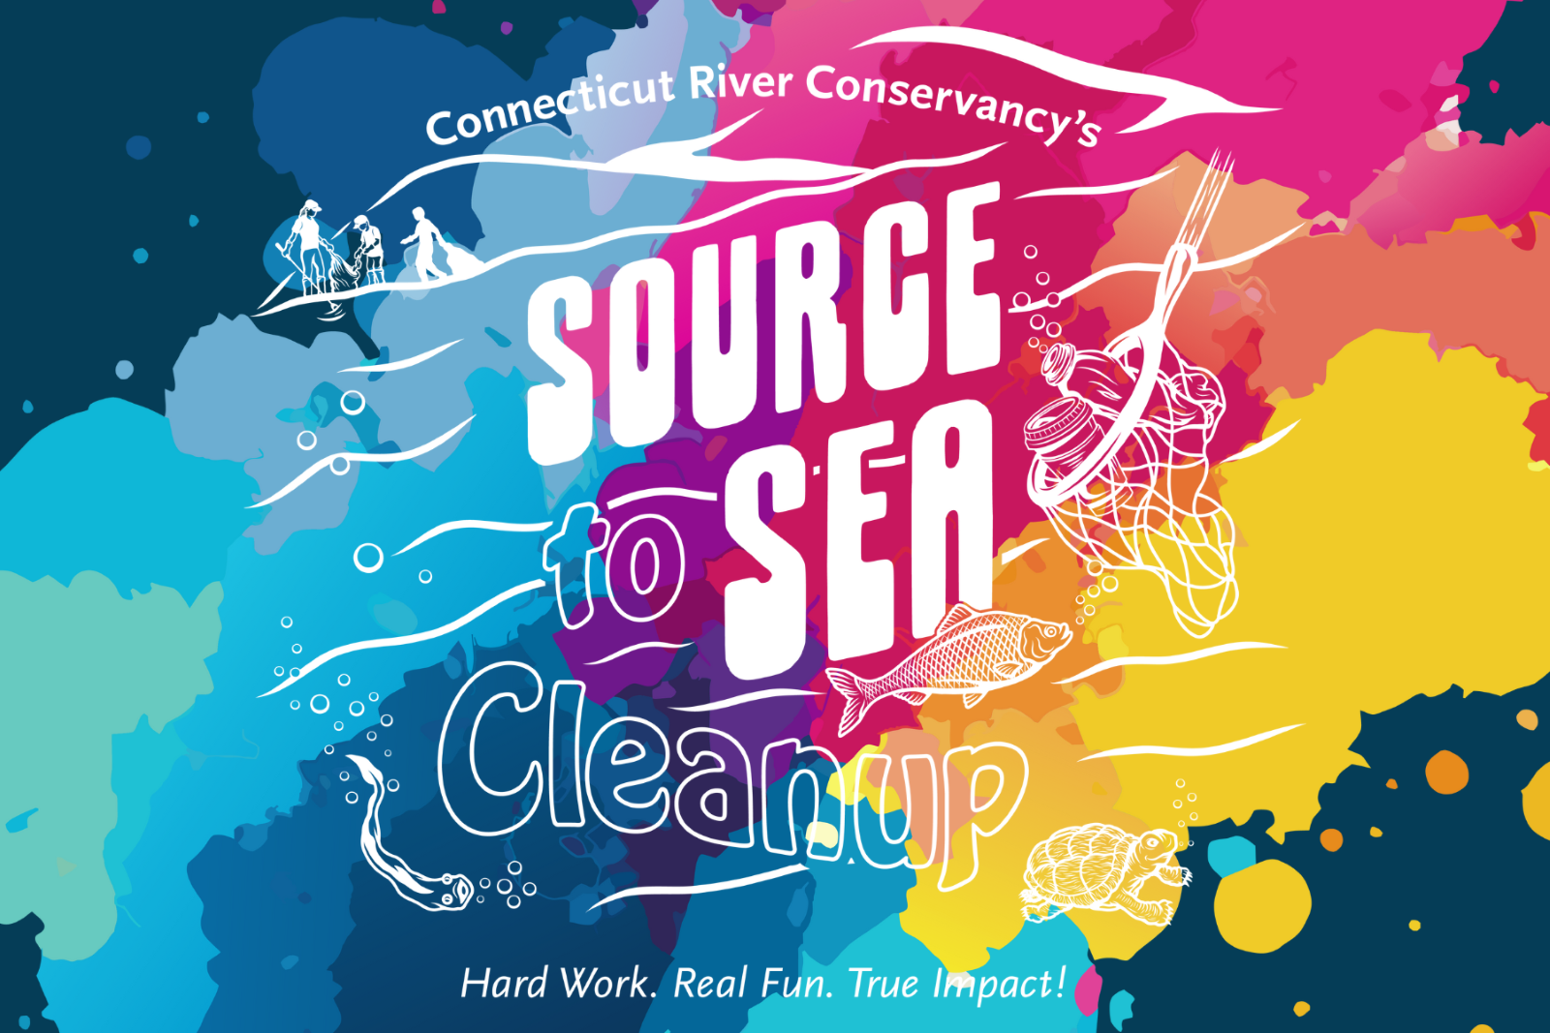

“*[add a quote here from someone local who will be participating with you or has participated in the past]” -name, title if applicable*

CRC promotes #RiverWitness to help people connect with each other online through their shared concern for and appreciation of our rivers. Take a photo or video when you are at the river, participating in the Source to Sea Cleanup, or enjoying time outside. Or make art inspired by river beauty or river pollution. Share on Instagram, include #RiverWitness and tag @ctriverconservancy.

*“The Source to Sea Cleanup is a fabulous opportunity to roll up your sleeves, work with others in your community, and clean up our waterways and city streets,” says CRC’s Cleanup Coordinator, Stacey Lennard. “When you pick up trash you are diverting that waste from going down storm drains and into the river system, which eventually flows into the ocean. You are ensuring that we keep this debris out of our rivers and oceans.”*

Group leaders who need help finding a cleanup site can check out CRC's map of adoptable trash sites. Or they can choose a site of their own by submitting a “Report a Trash Site” form. Parks, city blocks, boat ramps, and neighborhood hangouts are typically great spots to clean. Trash travels, so even picking up litter off a city sidewalk can help protect wildlife and communities that depend on clean waterways. Leaders are encouraged to scout the site out beforehand to determine if it’s suitable for their group. A handy Group Leader Guide is available for download on the Source to Sea website and provides all the necessary information and forms for running a successful cleanup.

Connecticut River Conservancy thanks the following sponsors for supporting this initiative – in some cases for many years! Lead sponsors in 2024 are The Walker Group, Eversource, USA Waste & Recycling Inc., and All American Waste. With additional support from Hypertherm HOPE Foundation, AFI Furnishings, Connecticut River Gateway Commission, Enterprise Holdings, Great River Hydro, LLC., Greenfield Savings Bank, GZA GeoEnvironmental, Inc., Savings Bank of Walpole, Ashuelot River Hydro, LLC., Chroma Technology, Florence Savings Bank, Fuss & O’Neill, Guilford Savings Bank, Jamrog HVAC, King Arthur Baking, Rare Forms, Inc., Reynold’s Boats & Reynold’s Subaru, SLR, SWCA Environmental Consultants, and Walmart Northampton & Hadley.

For more information, visit [CRC’s cleanup info page](https://www.ctriver.org/our-work/source-to-sea-cleanup/).

Sign up for [group name] here.

To sign up as a volunteer or group leader, view the [Cleanup Sites Map here](https://sourcetoseacleanup.org/cleanup-sites/).

For any questions about getting involved, contact Stacey Lennard at [cleanup@ctriver.org](mailto:cleanup@ctriver.org).

**About [your group]:**

**About Connecticut River Conservancy:**

The Connecticut River Conservancy (CRC) restores and advocates for clean water, healthy habitats, and resilient communities to support a diverse and thriving watershed. CRC has been a steward of the Connecticut River and tributary streams since 1952. Their programs include advocacy, aquatic invasive species management, dam removal, habitat restoration, migratory fish surveys, recreation, trash cleanups, and water quality monitoring. Together through community engagement and education, they’re dedicated to ensuring equitable access and healthy rivers for all. Learn more at [ctriver.org](http://ctriver.org/).

**Photos from past Source to Sea Cleanups [replace with your own photos if you have them, or keep the below if you don’t]:**

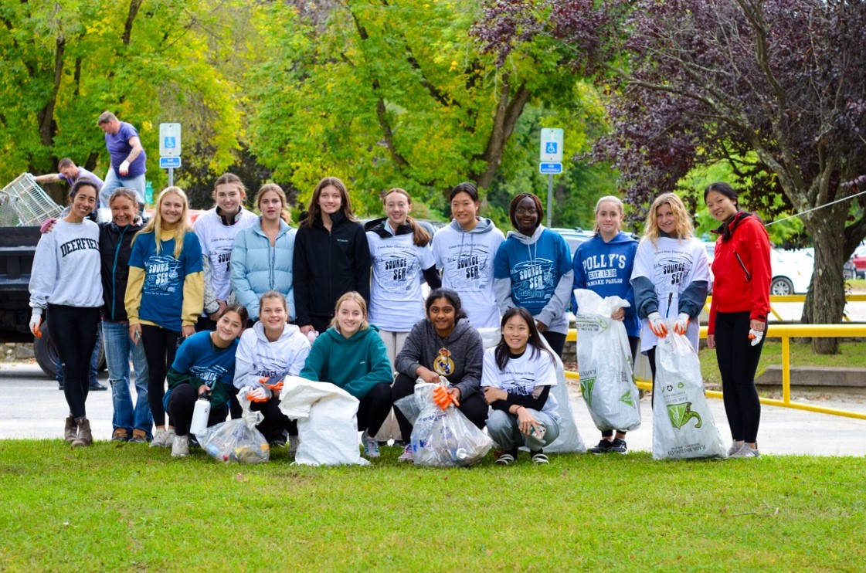

Photo Credit @Connecticut River Conservancy

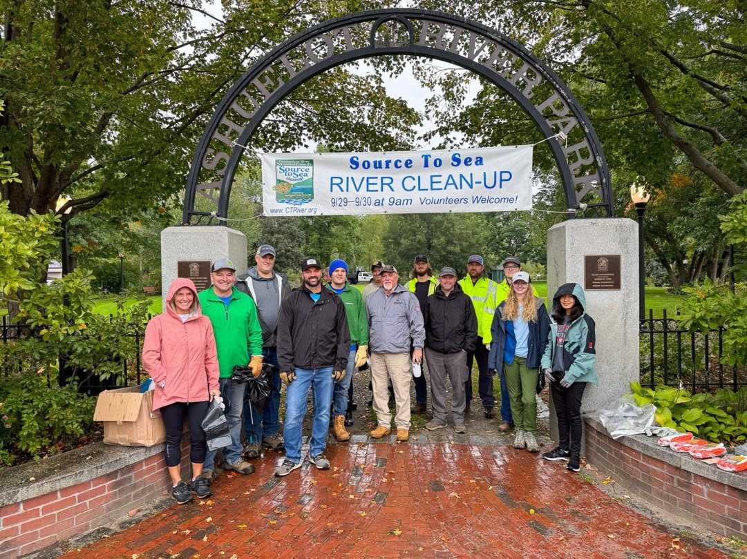

Photo Credit @Eversource NH

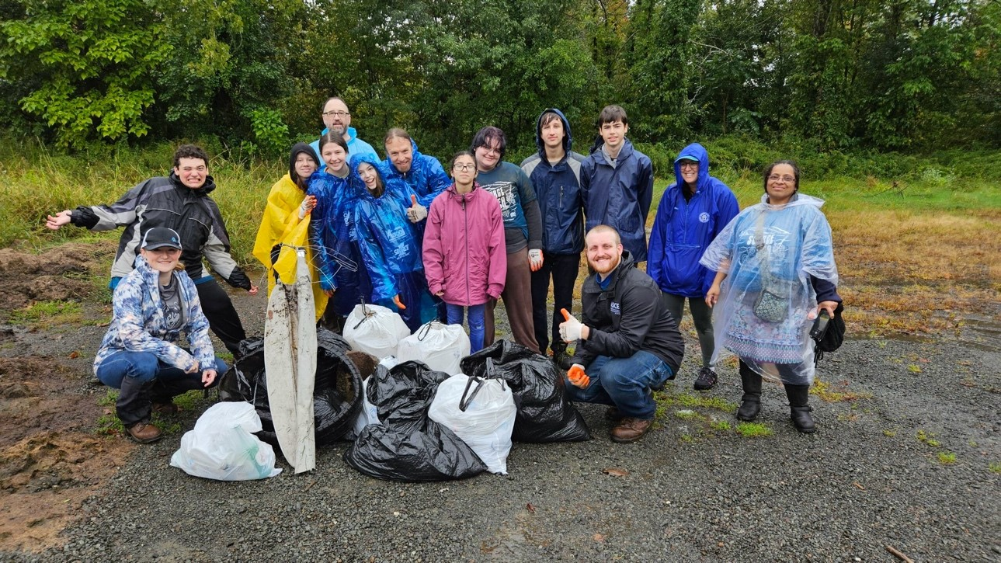

Photo Credit @SLR CT